A Feature Model for Exploratory Search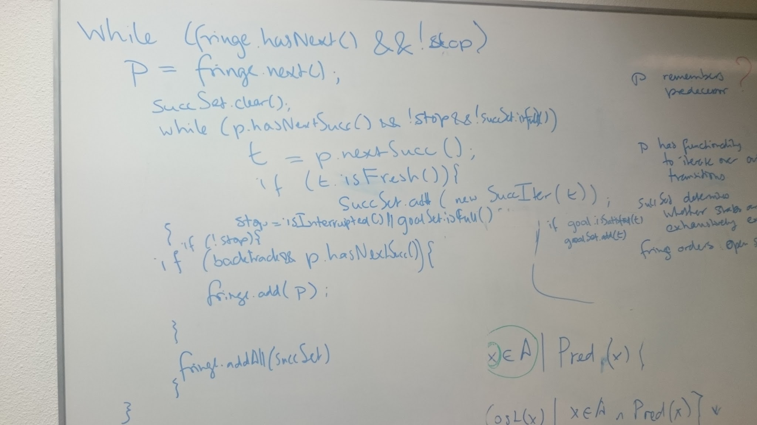
We adhere to the assumption that exploration always starts with a fresh (empty) state space. If a user wants to explore from a given state onwards, he can do this by saving that state and starting a new exploration.
- Selection of next state to explore: This refers to the choice of a state from the frontier, which is the next to be explored. The choice is only made between candidates that have the same quality, in case a heuristic is used - see below. Possible values are:
  - Oldest (giving rise to a breadth-first search)
  - Newest (giving rise to a depth-first search)
  - Random
Transient states are never put into the frontier; essentially, their exploration is done in a nested fashion, as part of the generation of successors.
- Selection of successor(s): given a selected next state to explore, there is a choice which of its successors to generate (and put into the frontier). Possible values are:
  - Single-InOrder: the first unexplored successor state
  - Single-Random: a single randomly chosen unexplored successor state
  - All-InOrder: All unexplored successor states, in their natural order
  - All-Random: All unexplored successor states, in random order
In case of Single-InOrder and Single-Random, the state will be put back into the frontier as long as it has further, unexplored outgoing transitions (unless the frontier is restricted to a single member only, see below). If the next-state selection strategy is Oldest, the only sensible successor selection strategies are All-InOrder or All-Random, and if it is Random, the only one is All-InOrder (as randomisation already takes place in the frontier). For Newest, on the other hand, though the First-* strategies would seem to be natural, actually the All-* have a lower memory footprint and so from that perspective remain attractive.
- Frontier size: this refers to the number of unexplored states kept in the frontier. Possible values are:
  - Single: This gives rise to a linear search. The next-state selection strategy is now irrelevant, since there can never be more than one state in the frontier.
  - Beam: To accommodate beam search, the max frontier size can be restricted to some upper bound larger than 1.
  - Complete: In case no states are to be ignored during state space exploration.
Both Single and Beam mean that the state space might not be explored fully - in fact, that is their purpose.
- Heuristic: this refers to a function that expresses the “quality” of a state, typically by returning the estimated distance (in terms of length or cost of a path) between a given state and the desired goal. The smaller the value, the “better” the state. There is a strong connection between heuristic and goal type. Possible values are:
  - None: No heuristic is used, or equivalently, all states have the same value
  - NEN: Count of Node/Edge/Node tuples. Only usable if the goal is given as a complete graph or unnested, NAC-free rule.
  - Abstraction-based distance of various kinds
  - … this is actually a very open area.
- Cost: This refers to the cost of a single transition. It is a factor typically used in planning. If transitions have cost, then the total cost of a path plays a role in exploration: the task is to find the least costly solution. Possible values are:
  - None: Then the cost of a path is ignored.
  - Uniform: Then the cost of the path equals its length.
  - Rule: Each rule application has a cost, which may either be fixed for the rule or be exposed as a rule parameter. Which of these two is used can be determined per rule.
It should be noted that the combination of cost with a non-monotonic heuristic makes the search algorithm quite a bit more complicated, as it is then possible that previously explored states are later reached again along a cheaper path, and so have to be explored again.
- Goal: This refers to a condition that determines whether a result has been found, together with the desired outcome to satisfy or violate that condition. Possible values are:
  - None: There is no goal, exploration will always continue until the frontier is empty. (For this goal type, the desired outcome must equal satisfy).
  - Final: A state has no outgoing transitions. (For this goal type, the desired outcome must equal satisfy).
  - Graph: The state graph should be isomorphic to a given graph. (For this the graphs in the graph view can be used.)
  - Rule: The state graph should satisfy a given rule condition
  - Formula: A propositional formula built from elements above
  - LTL formula
  - CTL formula
Note that (in connection to the above, but as a separate action) the rule conditions should visually be kept more separate from the rules.
- Result type: This refers to the type of result the search is supposed to yield. Possible values are:
  - State
  - Trace
(Note that the notion of trace can do with some additional support, such as storing or playing back a trace. This begs the question how a trace should be characterised, also taking recipe transitions into account.)
- Result count: This refers to the condition under which exploration may stop altogether. (Note that exploration will anyway stop when the frontier is empty.) Possible values are:
  - First: This means exploration stops as soon as a single result (satisfying the goal) is found
  - Count: This means exploration stops as soon as the indicated number of results (larger than 1) have been found
  - All: This means that exploration continues until the entire state space has been explored
- Bound: This limits the depth of the state space that will be explored, or imposes a certain ordering. The bound is a combination of
  - Function to compute the value of a given state. This can be one of
    - None: There is no bound, the state space is explored up to arbitrary depth
    - Cost: the cost of the path (see above - obviously, this only applies if Cost is not None)
    - Graph size: The total number of graph elements
    - Node and edge counts of certain (selected) graph element types
  - Maximum: the value of Function beyond which states are not explored (or exploration is delayed)
  - Increment: if larger than zero, exploration continues with larger graphs once all states below the bound have been explored, up to the incremented maximum; and so on. Used for iterative deepening.
- Persistence: This refers to the degree to which previously discovered states are stored. The GTS currently has the built-in assumption that states are never removed; moreover, a state is added to the GTS as soon as it is discovered. One can imagine that, instead, new states are initially only put in the frontier, and are added to the GTS only when closed. This would then open the possibility of not putting them in the GTS; so possible values would be
  - All: All states are stored in the GTS
  - None: No states are stored in the GTS
- State collapse: This refers to the condition under which a fresh state is considered to be equivalent to one explored before. The variation lies in the comparison between the underlying graphs; other state properties, such as the control frame, need to coincide as well. Possible values are:
  - Equality: The strongest possible condition
  - Isomorphism: Graphs are checked up to isomorphism
  - Hash: Graphs are considered to be equivalent if their iso hash code coincides. This may collapse non-isomorphic states, but saves time in that it is not necessary to reconstruct the actual isomorphism
Possibly weaker hash codes can be considered as well, at the price of losing the underlying morphism.
- Matcher: Any of
  - Plan (in which case you can set the common and control edge types to tune the search plan)
  - Rete (which is currently incomplete)
- Algebra: Any of
  - Default
  - Big
  - Point
  - Term

